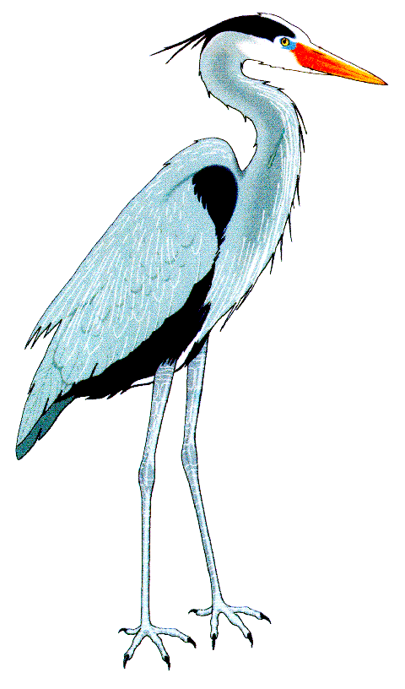
Shirwell Community Primary School
School Charging and Remissions Policy

This Policy describes the circumstances when the parents of children at this school will be asked to pay for school activities, when they will be asked to make a voluntary contribution to costs and when they will not be asked to pay or contribute.
It also describes Remission; when costs will be waived for children from low income households.

Text that is underlined in blue indicates a link to further information within the document or online. If you don’t have access to the internet or have any questions about this Policy, please ask for advice from the school.

Charging and Remissions Policy

Section | Contents | Page
Description of this Policy |  | 1
1 | Equality and Safeguarding Statements | 3
2 | Introduction | 3
3 | Responsibilities | 3
4 | Policy Statement | 3
5 | Voluntary Contributions | 3
6 | Optional activities outside of the school day | 4
7 | Education partly during school hours | 4
8 | Music Tuition | 4
9 | Residential Trips | 5
10 | Remission | 5
11 | Calculating Charges | 6
12 | Policy version | 6
13 | Contacts for further information | 6

1 | Equality and Safeguarding Statements
1.1 | This school and Devon County Council will only commit to policies and practices which will eradicate discrimination and promote equality for all, regardless of age, gender, disability, religion and belief, race and ethnicity and sexual orientation. This policy will be subject to an Impact Assessment which will be integral to all reviews.
1.2 | We and our partners recognise that safeguarding is everybody’s responsibility. Whether their interest is in all young people ‘staying safe’ in all aspects of our services, or whether they are working in specific areas of vulnerability, all staff will have appropriate training and induction so that they understand their roles and responsibilities and are confident in carrying them out. Settings, schools, children, young people and their parents or carers, or any member of the community should feel secure that they could raise any issues or concerns about the safety or welfare of children and know that they will be listened to and taken seriously. This will be achieved by maintaining an ethos of commitment to safeguarding and promoting the welfare of children and young people. This is supported by a clear child protection policy, appropriate induction and training, briefings on and discussion of relevant factors and refreshed learning in line with current legislation and guidelines.
2 | Introduction
2.1 | The purpose of the Policy is to ensure that there is clarity over those items which the school will provide free of charge and for those items where there may be charge.  The Policy has been informed by the Department for Education Guidance “Charging For School Activities” which was last updated in October 2014.
3 | Responsibilities
3.1 | The head teacher will ensure that staff are familiar with and correctly apply the policy. The Governors will review the policy from time to time to ensure that it meets with current guidance from the Department for Education.
4 | Policy Statement
4.1 | All activities that are a part of the National Curriculum for compulsory school age children, necessary as part of a syllabus for a prescribed public examination that the pupil is being prepared for at school, or part of religious education will be provided free of charge. This includes any materials, equipment, and transport to take pupils between the school and the activity.  We will normally make a charge unless the teaching is an essential part of either the National Curriculum or a public examination syllabus being followed by the pupil(s) at school,
5 | Voluntary Contributions
5.1 | We will ask parents to make a voluntary contribution towards costs for activities during the school day which entail additional costs (for example school trips). If the activity cannot be funded without voluntary contributions it will be made clear when parents are initially informed about the planned activity that this is the case. . The head teacher or teacher will also make it clear to parents that there is no obligation to make any contribution.  No pupil will be prevented from participating because his/her parents cannot or will not make a contribution. However, if insufficient funds are available it may be necessary to curtail or cancel activities or trips.  From time to time we may invite a non-school based organisation such as a theatre company to arrange an activity or performance during the school day. Such organisations may wish to charge in these circumstances the school may ask for a voluntary contribution from parents.
6 | Optional activities outside of the school day
6.1 | We will charge for optional, extra activities provided outside of the school day. Such activities are not part of the National Curriculum, part of a syllabus for a prescribed public examination that the pupil is being prepared for at the school or part of religious education. Examples are sports activities, theatre visits and extended day services such as the before and after school club. Charges will be based on the cost incurred less any specific funding received, except the before and after school club which will be charged at a commercial rate.
7 | Education partly during school hours
7.1 | A charge will only be made for the activity outside school hours if it is not part of the National Curriculum, not part of a syllabus for a prescribed public examination that the pupil is being prepared for at the school and not part of religious education.  A) Non-Residential  Where less than 50% of the time spent on activity falls during school hours, it is deemed to have taken place outside school hours.  B) Residential  If the number of school sessions taken up by the visit is equal to or greater than 50% of the number of half days spent on the visit, it is deemed to have taken place during school hours (even if some activities take place late in the evening).
8 | Music Tuition
8.1 | Charges may be made for teaching either an individual pupil or groups of any appropriate size to play a musical instrument or to sing. Charges may only be made if the teaching is not an essential part of either the National Curriculum or a public examination syllabus being followed by the pupil(s), or the first access to the Key Stage 2 Instrumental and Vocal Tuition Programme (Wider Opportunities).
9 | Residential Trips
9.1 | There will be no charge for:  - Education provided on any visit that takes place during school hours:  - Education provided on any visit that takes place outside school hours if it is:  - part of the National Curriculum, or  - part of a syllabus for a prescribed public examination that the pupil is being prepared for at the school, or  - part of religious education; and  - supply teachers to cover for those teachers who are absent from school accompanying pupils on a residential visit.  The school will charge for:  Board and lodging (the charge will not exceed the actual costs).
10 | Remission
10.1 | When parents are informed about a forthcoming visit, it will be made clear that parents who can prove they are in receipt of any of the following benefits will be exempt from paying the cost of board and lodging:  - Universal Credit in prescribed circumstances;  - Income Support (IS);  - Income Based Jobseekers Allowance (IBJSA);  - Support under part VI of the Immigration and Asylum Act 1999;  - Child Tax Credit, provided that Working Tax Credit is not also received and the family’s income (as assessed by Her Majesty’s Revenue and Customs) does not exceed £16,190 (Financial Year 2013/14);  - The guarantee element of State Pension Credit; and  - An income related employment and support allowance that was introduced on 27 October 2008.  (The criteria that entitle families to an exemption from paying for the cost of board & lodging has been aligned with free school meals criteria.)  The Governors have agreed that children who are not covered by the Remission Policy above may be subsidised in accordance with need, as identified by the Headteacher, so that no child is discriminated against. All applications for support/special consideration should be made direct to the head teacher.
11 | Calculating Charges
11.1 | When charges are made for any activity, whether during or outside of the school day, they will be based on the actual costs incurred, divided by the total number of pupils participating. There will be no levy on those who can pay to support those who are unable to or do not wish to pay.

Policy version:
This policy was determined by the Governing Body on 6th June 2017. It will be reviewed and determined annually.

Contacts for Further Information

School contact information: Shirwell Community Primary School
School Lane
Shirwell
Barnstaple
EX31 4JT
Telephone: 01271 850295
Email: admin@shirwell.devon.sch.uk

The Department for Education (DfE)
0870 000 2288 www.education.gov.uk

The Education Funding Agency (EFA) - Bristol
0370 000 2288 www.education.gov.uk/b00199952/educationfundingagency

The national curriculum is a set of subjects and standards used by primary and secondary schools so children learn the same things. It covers what subjects are taught and the standards children should reach in each subject.
Children reach compulsory school age on the prescribed day following their 5th birthday (or on their fifth birthday if it falls on a prescribed day). They must be in full time education by the beginning of the term following this. The prescribed days are 31 August, 31 December and 31 March. Children who are of compulsory school age do not have to be in school – they may be Home Educated.
Under The Education (School Day and School Year) (England) Regulations 1999, the school day is split into two half-day sessions, whatever time it starts and finishes. A school half day is any length of time up to 12 hours when the school meets, ending at noon or midnight that day. At this school, the session times are: Morning from 8.45am to 12.15pm Afternoon from 1.25pm to 3.30pm
For further information, see www.education.gov.uk/publications/eOrderingDownload/0184-2006PDF-EN-01.pdf

